QR-Based Cattle Management System: A Platform for Personalized Health Monitoring Using Composite Health Deviation Index (CHDI)

1st Mrs. J. Deepika
Department of Information Technology
Sona College of Technology, Salem
Tamilnadu, India
deepika@sonatech.ac.in

4th Sujeeth Y R
Department of Information Technology
Sona College of Technology, Salem
Tamilnadu, India
Sujeeth.23ads@sonatech.ac.in

2nd Sabari Karthick A
Department of Information Technology
Sona College of Technology, Salem
Tamilnadu, India
sabarikarthick.23ads@sonatech.ac.in

3rd Sivanarasimman S
Department of Information Technology
Sona College of Technology, Salem
Tamilnadu, India
sivanarasimman.23ads@sonatech.ac.in

Abstract—QR Based Cattle Management System is a low-cost, web-based livestock management system that provides individual-animal identification and digital health-record management for livestock. Each animal is assigned a unique cattle identifier in the form of a QR tag that can be scanned with a phone camera and used to retrieve the animal's digital profile. The system integrates QR-based identification, centralized cattle records, role-based access, medical and vaccination history, alerts, and personalized health-deviation analysis. The proposed system uses an individual baseline for each animal, derived from its own history, rather than relying solely on population-level thresholds. A Cattle Health Deviation Index (CHDI) is derived by combining the personalized deviations of new observations into a single composite score. Temporal trend analysis is used to determine whether an animal's health condition is improving, stable, deteriorating, or fluctuating. The framework also integrates anomaly detection, machine-learning-based risk assessment, explainability, uncertainty estimation, and multi-signal confirmation. These components are designed to assist veterinarians working with limited and incomplete field observations. The QR layer offers a convenient, infrastructure-light interface for smallholder farms, since dedicated QR readers and per-animal sensing equipment are not required. The platform further provides three role-based interfaces—for farmers, veterinarians, and administrators—each scoped to its respective function, from routine data logging to case review and system-wide oversight. Veterinarian confirmation or override of each flagged case is captured as feedback, allowing the underlying risk model to be refined over time rather than remaining static. The system is not intended as a diagnostic tool, but rather as a decision-support system.
Keywords—QR Code, Cattle Management, Livestock Identification, Personalized Health Baseline, CHDI, Anomaly Detection, Machine Learning, Precision Livestock Farming, Veterinary Decision Support, Uncertainty Estimation.

I. INTRODUCTION
The identification of individual livestock with a high degree of certainty, together with the maintenance of information on health status, vaccination status, ownership, production, and veterinary history, is essential for livestock management. Traditional management practices often rely on physical identification and manual record keeping. As animal numbers increase, it becomes progressively more difficult to locate and update individual animal records, which can reduce the efficiency of farm management.
The introduction of new technologies into modern livestock-management systems has provided farmers with a wealth of tools for monitoring livestock, including RFID, IoT sensors, computer vision, machine learning, and cloud-based platforms. Many of these, however, require a dedicated reader, sensing equipment, continuous connectivity, or other infrastructure. Such infrastructure can be impractical for smallholder and low-resource farms because of its cost and complexity.
The entry point of the proposed system is intentionally simple: individual-animal identification realised through QR codes and linked to a digital platform for livestock management. A unique QR tag is assigned to each animal. The tag can be scanned using a smartphone camera, and the resulting identifier is resolved to a specific cattle profile. The QR payload contains only the animal identifier and no medical data, which ensures that sensitive health and medical information remains protected behind authentication and role-based access control.
A significant technical dimension of the proposed system is personalized health assessment. In conventional health monitoring, the normality of a measurement is often decided using a fixed set of population thresholds. However, two animals could share the same absolute measurement while that measurement carries a different clinical significance for each, depending on their individual histories. The proposed approach instead establishes an individual baseline from each animal's own prior observations, and personalized deviations are derived for each health variable rather than relying solely on population-level thresholds.
The system also accounts for the temporal characteristics of health observations. A single abnormal reading is not sufficient to conclude deterioration, especially when the number of field readings is small or incomplete. The proposed framework therefore integrates individual deviations, the CHDI, temporal trend analysis, anomaly detection, and multiple supporting signals. An uncertainty mechanism is also included so that the system can express uncertainty about its assessment rather than produce an unreliable personalized conclusion.
This work investigates whether a low-cost, QR-based identification layer can be coupled with adaptive personalized health baselines, longitudinal deviation features, anomaly detection, machine-learning risk prediction, uncertainty estimation, and multi-signal confirmation to practically support early detection of health deviations in cattle under low-infrastructure and incomplete-observation conditions. The aim is to assist veterinary decision-making, not to substitute for veterinary diagnosis.
II. PROBLEM STATEMENT AND OBJECTIVES
A. Problem Statement
Current livestock management solutions often struggle with manual identification, paper-based recording, dedicated hardware for RFID tags, sensor deployment costs, incomplete observations, and the interpretation of individual animal health status. What is normal for one animal may represent a substantial change for another when compared against its own historical health record.
It is therefore essential to design a system that solves the challenge of creating a simple identification and decision-support platform that links each animal to a continual digital record, and that can analyze health observations on the basis of personalized baselines.
B. Objectives
The major objectives of this work are:
1) To assign each animal a unique identification code via a QR code.
2) To enable smartphone-based access to a cattle profile without requiring dedicated RFID readers.
3) To maintain cattle, health, medical, veterinary, and ownership records in a central location.
4) To build a longitudinal health-observation database for each individual animal.
5) To compute individual deviations for the relevant health parameters.
6) To calculate a composite Cattle Health Deviation Index (CHDI).
7) To examine the temporal trend of health deviations.
8) To detect health abnormalities through anomaly detection.
9) To explore machine-learning risk prediction using derived health features.
10) To provide an explainable rationale behind machine-learning outputs.
11) To assess confidence based on data coverage and historical depth.
12) To provide alerts and prioritized information to assist veterinarians in decision-making.
III. PROPOSED SYSTEM
The proposed system consists of a low-cost QR identification layer and a cattle-health analysis pipeline customized for each individual animal. The overall processing sequence is as follows: an animal is scanned via its QR tag; the identifier is resolved in the Cattle Identification process; the user's authentication and role are verified in the Cattle Profile process; new observations are checked for missing data in the Missing-Data Handling process; the animal's baseline is retrieved or updated in the Individual Baseline process; deviations are computed in the Personalized Deviation process; and the composite score is computed in the CHDI process, followed by trend analysis, anomaly detection, and alerting.
The QR code serves as a gateway to the animal's online profile. A unique cattle ID, encoded into the QR tag, is assigned to each animal. When the QR code is scanned, the embedded identifier is used to look up the animal, verify that the user holds the appropriate permissions, and load the cattle profile.
The QR code carries only this identifier — it does not directly store medical information. This design ensures that detailed health information is never exposed on the physical tag and instead remains stored within the secure backend database. In addition, scanning with an ordinary smartphone eliminates the need for dedicated RFID readers, further reducing the infrastructure requirement for smallholder farms.
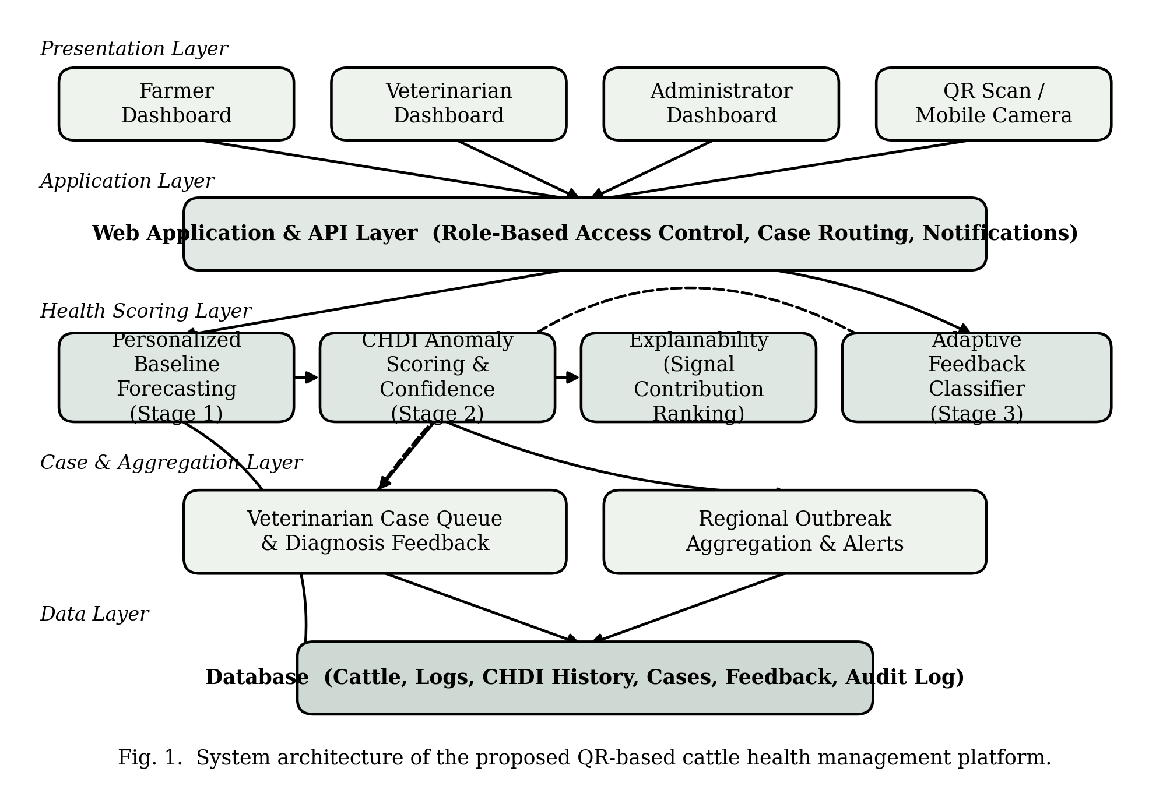
Fig. 1. System architecture of the proposed QR-based cattle health management platform.

IV. SYSTEM MODULES
A. User Management Module
This module provides authentication and role-based access control for administrators, farmers, and veterinarians. Access to cattle and health information is restricted according to each user's authorized role.
B. Farm Management Module
This module manages information about individual farms and links each animal to the farm on which it is kept, providing a structured way to organize livestock data.
C. Animal Husbandry Module
This module stores individual animal profiles containing identification and other relevant cattle information. Each animal is linked to a unique QR tag, creating a persistent association between the physical tag and the digital record.
D. QR Code Generation and Identification Module
This module generates a unique identifier and corresponding QR code for every animal. The QR code serves as the animal's physical ID, and a smartphone is used to scan it and retrieve the associated profile.
E. Health Parameter Measurement Module
This module records measurements of temperature, heart rate, respiratory rate, weight, milk yield, activity level, body condition, and other clinical observations.
F. Medical and Vaccination Management Module
This module maintains records of diagnosis, treatment, medication, vaccination, veterinary observations, and follow-up information.
G. Personalized Health Analysis Module
A baseline is established for each animal from its previous health observations. New measurements are compared against the animal's own historical mean and standard deviation rather than against population-level thresholds.
H. CHDI Module
The Cattle Health Deviation Index (CHDI) combines the available individual health deviations into a single normalized composite score. Missing observations are excluded from the computation rather than treated as normal. In the research prototype, the following weights are proposed: temperature 0.25, respiratory rate 0.15, weight 0.15, milk yield 0.20, activity 0.15, and heart rate 0.10. These weights are prototype values for research purposes and have not been clinically validated.
I. Trend Analysis Module
The trend engine analyzes recent CHDI values using the slope of the observed time series. The output is classified as Improving, Stable, Deteriorating, Fluctuating, or Insufficient Data.
J. Anomaly Detection and Risk Analysis Module
This module detects unusual patterns using engineered features such as personalized deviations, CHDI, CHDI slope, and rolling variance. The anomaly detector is intended to flag abnormal patterns, not to diagnose disease. When reliable labeled data is available for a well-defined health event, a supervised XGBoost model may additionally be used for risk prediction.
K. Explainability and Uncertainty Module
SHAP is used to identify the features driving the output of the machine-learning models. The uncertainty mechanism accounts for history length, data completeness, data recency, baseline stability, supporting signals, and measurement consistency. When historical data is insufficient, the system returns an insufficient-evidence state rather than a potentially misleading confidence value.
L. Alert and Notification Module
This module generates prioritized alerts when abnormal patterns, deteriorating trends, upcoming vaccination events, or veterinary follow-ups require attention. Alert levels reflect system priority and are not a clinical classification of disease severity.
V. EXPERIMENTAL SETUP
The experimental setup comprises a QR identification layer, a web application, a backend API, a centralized database, health-analysis components, and a smartphone-based scanning interface.
The pipeline begins with an animal being registered and assigned a unique QR identifier. Using a smartphone camera to scan the identifier, the cattle profile is retrieved after successful authentication and role verification.
Health observations are recorded longitudinally for each animal. Missing-data handling is applied to the available observations, after which personalized deviations are computed. The personalized deviation of health variable j for animal i at observation time t is defined as:
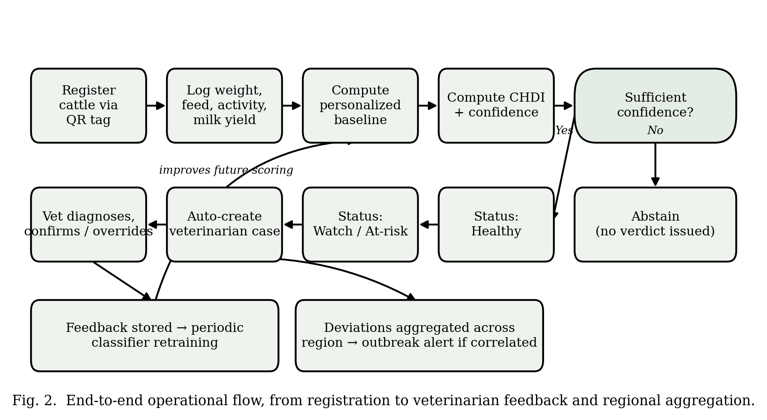
Fig. 2. End-to-end operational flow, from registration to veterinarian feedback and regional aggregation.

D(i, j, t) = [X(i, j, t) − μ(i, j)] / [σ(i, j) + ε](1)
Here, X(i, j, t) is the current observation, and μ(i, j) and σ(i, j) are the historical mean and standard deviation, respectively, for that animal and variable. The small constant ε prevents division by zero.
Appropriate directions of deviation are used for different variables: absolute deviations are used for temperature, heart rate, and respiratory rate, while decreases in weight, milk yield, and activity are treated as potentially concerning directional changes.
The CHDI combines the available normalized health deviations using the pre-determined prototype weights described in Section IV-H. Missing observations are excluded rather than treated as normal, and the resulting index is rescaled to a 0–100 range. The proposed research thresholds — not clinical diagnostic thresholds — are 0–29 for low, 30–59 for moderate, and 60–100 for high system-priority deviation.
To assess trends, the slope of recent CHDI observations is computed by least-squares regression. The resulting trend is classified as improving, stable, deteriorating, fluctuating, or insufficient data.
Engineered features — including deviations, CHDI, CHDI slope, rolling variance, observation count, and data completeness — are used to train an Isolation Forest model for unsupervised anomaly detection. When a well-defined, reliably labeled health event is available, a supervised XGBoost model can additionally be trained. At the animal level, training and testing sets are drawn from different animals so that no animal appears in both sets.
VI. RESULTS AND DISCUSSION
The proposed system is a framework that links a single cattle identification layer to longitudinal digital health analysis. The QR layer offers a lightweight way to retrieve an animal's profile, and the individualized baseline allows an animal's health observations to be compared against its own historical health rather than a fixed population norm.
A drawback of fixed population thresholds is addressed through the personalized-deviation approach. Because the normal physiological range differs across animals, comparing each observation to the animal's own prior observations offers a more individualized picture of change.
The CHDI combines several available health indicators into a single normalized system score. No automatic assumption is made about missing observations being normal, since only available measurements are used. The trend engine adds temporal context, allowing the system to distinguish isolated changes from sustained deterioration.
Multi-signal confirmation further considers how many of the available health signals are simultaneously abnormal relative to the total available, which can help distinguish an isolated aberration from a set of coordinated abnormal signals.
The anomaly-detection component is intended to flag anomalies, not to diagnose disease. Similarly, machine-learning risk prediction is intended to be tied to a specific, identifiable, labelled health event rather than an unsupported disease-probability statement.
The uncertainty mechanism is essential when the number of available observations is low. When historical data is insufficient, the system does not provide a potentially unreliable confidence percentage; instead, it reports that there is insufficient historical evidence for a reliable personalized assessment.
Experimental Results
Actual experimental values are to be inserted following integrated testing of the system. Table I lists the evaluation metrics planned for this purpose; results are pending at the time of writing. Any simulated or demonstration values used prior to full deployment will be explicitly labelled as SIMULATED/DEMO DATA and will not be presented as measured experimental results.
TABLE I
PLANNED EVALUATION METRICS (RESULTS PENDING)
Evaluation Metric | Result
Number of animals tested | Pending
Number of observations | Pending
QR scanning success rate | Pending
Average record retrieval time | Pending
CHDI computation time | Pending
Anomaly detection performance | Pending
XGBoost performance | Pending
Data completeness | Pending
Number of correctly detected abnormal patterns | Pending

VII. LITERATURE SURVEY
1) Identification and Traceability of Cattle in Selected Countries Outside of North America
Bowling et al. review cattle identification and traceability systems in countries outside North America, describing mechanical methods (ear tags and branding), electronic methods (RFID ear tags, rumen boluses, and implantable transponders), and biometric methods. The paper highlights the link between identification and production management, disease control, ownership, trade, and consumer requirements, with centralized databases and lifetime movement records illustrated through examples from the EU and Australia.
This paper provides the historical and traceability basis for the proposed project: every animal must have a unique identifier that can be linked to a permanent digital record. The systems described, however, are largely regulatory or infrastructure-based and lack a smartphone QR interface and an integrated farmer-veterinarian health workflow.
Relevance / Gap: The paper establishes the need for unique identification, centralized records, and traceability, but relies on conventional or electronic traceability systems rather than smartphone-generated QR codes combined with an integrated health-management system, which is the gap the proposed project addresses.
2) RFID Technology for Animal Tracking: A Survey
Pereira et al. conduct a systematic review of scientific literature and patents related to RFID for animal tracking. The review finds that livestock management is the primary application area, cattle are the most commonly monitored animal, and passive UHF tags are most frequently used. The authors also identify opportunities for combining RFID with cameras and GPS, and they note the non-contact, non-line-of-sight reading capability of RFID and its suitability for individual animal tracking, alongside challenges such as cost, antenna performance, interference, and security.
This paper is particularly useful for positioning QR identification as an alternative when a dedicated RFID reader is undesirable, and it supports linking identification with health history, vaccination, and dietary data.
Key contribution: a systematic comparison of RFID-based animal tracking approaches, highlighting the opportunity for a reader-less, camera-based identification process that can be implemented using an ordinary smartphone with direct access to a centralized animal profile.
3) Computer Vision-Based Cattle Identification Using Body Texture, QR Code, and Numerical Labelling: A Comparative Evaluation
Bumbálek et al. compare QR-code-based identification directly with body-texture recognition and numerical labelling using YOLOv8. The study reports that QR-code collars are well suited to dynamic herds, since new animal codes can be assigned without retraining the model. The QR approach achieved an mAP50–95 score of 0.71, compared with 0.78 for body-texture recognition and 0.84 for numerical labelling. The study also identifies challenges such as occlusion, low image resolution, and adverse environmental conditions.
This paper is the most directly relevant to the proposed QR identification layer, as it evaluates QR codes under real cattle-identification conditions rather than treating QR purely as a data-storage layer.
Relevance / Gap: This study confirms the viability of QR-based identification while showing that environmental conditions can affect camera-based recognition accuracy. Accordingly, the proposed system should include weatherproof tags, a minimal QR payload, and a manual lookup/search fallback for cases where the QR code cannot be read.
4) Introduction of Digital Innovations in Livestock Farming
Subach and Shmeleva survey the digital transformation of livestock farming enabled by biometric sensors, big data, IoT platforms, artificial intelligence, and blockchain technology. Precision Livestock Farming, wireless sensor networks, and multi-agent technologies are presented as means of enabling non-invasive measurement, supporting pattern discovery, improving forecasting, reducing resource consumption, and enabling individualized animal-health management.
The paper also emphasizes the need to integrate devices with cloud-based systems and to apply data analytics in support of decision-making. It serves as a supporting reference for the overall architecture in which animal data is digitized, centrally stored, and converted into actionable management information for the proposed project.
Relevance / Gap: The paper addresses digitalization at a broad, technology-oriented level rather than a specific QR-based cattle-management implementation. It motivates the digital transformation required while leaving room for a realistic, low-cost implementation that combines identification, veterinary records, and farmer-oriented workflows.
5) Smart Neck Collar: IoT-Based Disease Detection and Health Monitoring for Dairy Cows
Kaur and Virk propose an IoT-enabled neck collar equipped with sensors for temperature, pulse rate, and activity. Data are transmitted wirelessly to a central database and analyzed using machine-learning algorithms for anomaly and health-pattern detection. Health parameters were collected from 150 dairy cows over two months across seven districts of Punjab, India; a random forest model and a decision tree model achieved reported accuracies of 92% and 91%, respectively. The paper also describes a Raspberry Pi-based deployment, cloud/server processing, and mobile alerts.
This work provides strong support for the health-analysis stage of the proposed system, particularly for collecting multiple health indicators and detecting potential health deterioration from historical patterns.
Relevance / Gap: A key limitation for the proposed project is the requirement for specialized collar sensor hardware. The proposed QR-based system can instead begin with digital or manual clinical readings and later be extended with IoT sensors. The paper also demonstrates the value of activity and physiological measurements for early health assessment.
6) Applications of Livestock Monitoring Devices and Machine Learning Algorithms in Animal Production and Reproduction: An Overview
Curti et al. present a comprehensive overview of sensors and of computer-vision and ML/DL applications in livestock production and reproduction. The paper outlines a five-step data cycle — acquisition, transfer, storage, analysis, and delivery of results — for livestock management.
This paper outlines a system-level approach for extending animal records into a complete data pipeline, which is directly applicable to the proposed project. It encourages the application of machine learning and monitoring technologies to health, behaviour, and production tasks.
Relevance / Gap: The survey is broad and not specific to QR identification. The principle it teaches is architectural: a livestock system must not only analyze health problems but also provide effective mechanisms to acquire, share, store, and deliver results to farmers.
7) Precision Livestock Farming Technologies in Pasture-Based Livestock Systems
Aquilani et al. review PLF technologies for pasture-based livestock, including RFID, walk-over weighing, thermography, GPS, accelerometers, remote sensing, and virtual fencing. The review notes that RFID is an early technology for individual identification, while GPS and accelerometers are widely used for location tracking, behaviour analysis, feed intake, and reproduction monitoring.
The paper also identifies practical limitations such as battery life, transmission range, service coverage, and storage cost and size. It is relevant because a cattle-management platform must remain usable in open field conditions rather than only in enclosed housing, and must account for the constraints of larger farms where cattle graze extensively.
Relevance / Gap: This review is centered on pasture-based systems rather than a specific QR or veterinary application. It shows that low-power, low-cost, and easily deployable methods are preferred, indicating that future iterations of the proposed project could incorporate GPS, additional sensors, or remote monitoring if required.
8) Pet Health Management System for GeBuu Veterinary Clinic
Ahmad and Salamat present an online system for managing pets, supporting owners, staff, veterinarians, and clinic suppliers. The system supports registration, appointment scheduling, vaccination and treatment history, medicine management, notifications, and reporting, using role-based user categories and a database-driven workflow.
Although designed for companion pets rather than cattle, the underlying record model is highly relevant to the proposed project: an animal record should include not only identification data but also medical history, vaccination and treatment information, and scheduled follow-ups. The paper also demonstrates the benefits of reminders and digital veterinary workflows.
Relevance / Gap: The main limitation is domain scope — this is a clinic-management system rather than a field-identification system for cattle, and it does not incorporate QR-code-based identification.
9) Combination of Multi-Agent Systems and Wireless Sensor Networks for the Monitoring of Cattle
Barriuso et al. introduce a multi-agent architecture that integrates wireless sensor networks for remote cattle monitoring. The system tracks factors such as physical activity, temperature, estrus, and calving, and provides applications for remote visualization. The architecture is designed for sensor nodes with limited computational capability and is built on PANGEA agent orchestration.
The paper also addresses battery efficiency, MQTT-based communication, and how sensor data is collected, analyzed, and delivered to mobile, web, or TV interfaces. This aligns with the future direction of the proposed project regarding IoT-based monitoring and a modular architecture.
Relevance / Gap: This system has considerably greater implementation complexity than the proposed QR-first platform. While the modular concept is retained in the proposed project, deployment can be simplified — QR identification and centralized records can be deployed first, with sensor-based analytics added in later phases.
TABLE II
SUMMARY OF REVIEWED LITERATURE AND RELEVANCE TO THE PROPOSED SYSTEM
Ref. | Focus | Core Approach | Key Limitation
[1] | Cattle ID & traceability (global review) | Mechanical/electronic/biometric IDs, centralized records | Regulatory/infrastructure-based; no smartphone QR interface or health workflow
[2] | RFID for animal tracking (systematic review) | Passive UHF RFID tagging | Requires dedicated RFID readers; not reader-less/camera-based
[3] | QR vs. body-texture vs. numeric ID | YOLOv8-based comparative evaluation | QR accuracy affected by occlusion/environment; no health-analysis layer
[4] | Digital transformation of livestock farming | IoT, big data, AI, blockchain (broad survey) | Broad/technology-level; not a specific QR-based implementation
[5] | Smart neck collar health monitoring | IoT sensors + RF/DT ML (92%/91% reported) | Requires specialized wearable collar hardware per animal
[6] | Livestock monitoring & ML overview | Five-step data cycle (acquire–deliver) | Broad/architectural; not QR- or personalized-baseline-specific
[7] | PLF technologies in pasture systems | RFID, GPS, accelerometers, thermography | Centered on pasture/field constraints, not a veterinary workflow
[8] | Pet health management system | Role-based clinic records (owners/vets/staff) | Designed for companion-pet clinics, not cattle; no QR identification
[9] | Multi-agent + WSN cattle monitoring | PANGEA agent architecture, MQTT sensor network | Considerably higher implementation complexity than the proposed QR-first platform

VIII. CONCLUSION
The literature review indicates a clear progression from manual cattle identification toward connected precision-livestock systems. Collectively, these works provide direct evidence for the necessity of unique, persistent animal records and automated identification (as shown by the RFID surveys), the promise of continuous health analysis (shown by the IoT and machine-learning studies), practical deployment constraints (shown by the PLF reviews), and the importance of vaccination, treatment, reminders, and role-based workflows (shown by the veterinary software study). These findings form a solid technical foundation for the proposed QR-Based Cattle Management System and its planned extension toward IoT and machine-learning integration.
REFERENCES
[1] M. B. Bowling, D. L. Pendell, D. L. Morris, Y. Yoon, K. Katoh, K. E. Belk, and G. C. Smith, “Identification and traceability of cattle in selected countries outside of North America,” The Professional Animal Scientist, vol. 24, pp. 287–294, 2008.
[2] E. Pereira, Í. Araújo, L. F. Vieira Silva, M. Batista, S. Júnior, E. Barboza, E. Santos, F. Gomes, I. T. Fraga, R. Davanso, D. O. dos Santos, and J. de A. Nascimento, “RFID technology for animal tracking: A survey,” IEEE Journal of Radio Frequency Identification, vol. 7, pp. 609–620, 2023, doi: 10.1109/JRFID.2023.3334952.
[3] R. Bumbálek, J. D. M. Ufitikirezi, T. Zoubek, S. N. Umurungi, R. Stehlík, Z. Havelka, R. Kuneš, and P. Bartoš, “Computer vision-based approaches to cattle identification: A comparative evaluation of body texture, QR code, and numerical labelling,” Czech Journal of Animal Science, vol. 70, no. 9, pp. 383–396, 2025, doi: 10.17221/66/2025-CJAS.
[4] T. I. Subach and Zh. N. Shmeleva, “Introduction of digital innovations in livestock farming,” IOP Conference Series: Earth and Environmental Science, vol. 1112, art. 012079, 2022, doi: 10.1088/1755-1315/1112/1/012079.
[5] D. Kaur and A. Kaur Virk, “Smart neck collar: IoT-based disease detection and health monitoring for dairy cows,” Discover Internet of Things, vol. 5, art. 12, 2025, doi: 10.1007/s43926-025-00109-5.
[6] P. de Freitas Curti, A. Selli, D. Lodi Pinto, A. Merlos-Ruiz, J. C. de Carvalho Balieiro, and R. Vieira Ventura, “Applications of livestock monitoring devices and machine learning algorithms in animal production and reproduction: An overview,” Animal Reproduction, vol. 20, no. 2, art. e20230077, 2023, doi: 10.1590/1984-3143-AR2023-0077.
[7] C. Aquilani, A. Confessore, R. Bozzi, F. Sirtori, and C. Pugliese, “Review: Precision Livestock Farming technologies in pasture-based livestock systems,” Animal, vol. 16, art. 100429, 2022, doi: 10.1016/j.animal.2021.100429.
[8] M. S. Ahmad and M. A. Salamat, “Pet Health Management System for GeBuu Veterinary Clinic,” Applied Information Technology and Computer Science, vol. 4, no. 2, pp. 1016–1033, 2023, doi: 10.30880/aitcs.2023.04.02.058.
[9] A. L. Barriuso, G. Villarrubia González, J. F. De Paz, Á. Lozano, and J. Bajo, “Combination of multi-agent systems and wireless sensor networks for the monitoring of cattle,” Sensors, vol. 18, no. 1, art. 108, 2018, doi: 10.3390/s18010108.

